FieldSync
Database Schema Design (Revised)
Aligned with the Authentication, Roles & Client System Guide
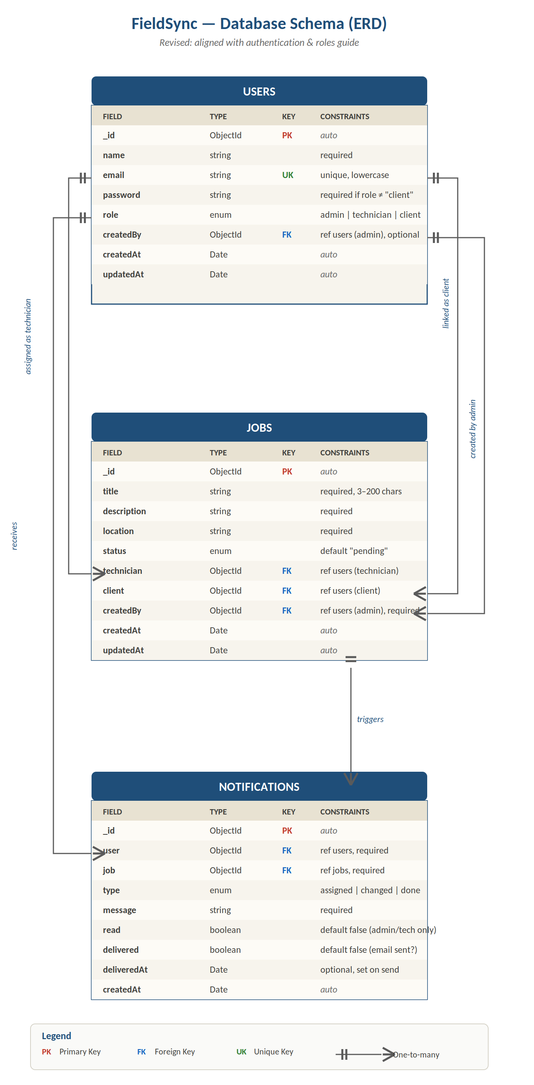
Figure 1. FieldSync ERD — revised schema

Overview
This schema is a revision of the original ERD, updated to match the Authentication, Roles & Client System Guide. The structure is still three collections — USERS, JOBS, and NOTIFICATIONS — but four targeted changes bring it in line with how the system actually behaves: clients don't authenticate, admins create everyone else, and notifications are sent to clients by email rather than viewed in an inbox.
Summary of revisions. Password on USERS is no longer required for clients. A new createdBy field on both USERS and JOBS records the admin who created the record. Foreign keys to USERS now explicitly state the expected role. NOTIFICATIONS gains delivered and deliveredAt fields to track email delivery, and the read field is now documented as meaningful only for admin and technician recipients.

What changed and why

1. Password is conditionally required
The guide states clearly that clients do not log in — they receive notifications by email but never authenticate. The previous schema marked password as required for all users, which would have made it impossible to create a client record without inventing a fake password.
The constraint now reads "required if role ≠ client." For admins and technicians it stays mandatory and stored as a bcrypt hash. For clients it is simply omitted.

2. A createdBy field on USERS
Admins are seeded manually into the database (per the guide), but technicians and clients are created by an admin through the admin dashboard. The new createdBy foreign key records which admin created any given account. It's optional because seeded admins won't have one — the first admin in the system was inserted directly by the team.
This is useful for accountability, gives the audit log stretch goal a foundation, and makes it possible to show "created by Ama" next to a technician's record in the admin dashboard.

3. A createdBy field on JOBS
Same idea applied to jobs. Every job is created by an admin (technicians don't create jobs, only update the status of jobs assigned to them). Recording the creator makes the data self-documenting and supports any future "jobs I created" view on the admin dashboard. Unlike the USERS version, this one is required — every job must have a creator.

4. Notification delivery tracking
The guide describes notifications as email messages sent to clients when job status changes. The original schema's read field made sense for in-app notifications but had no meaning for emails — there is no one to open the app and mark the email as read.
Two new fields handle email delivery cleanly: delivered (a boolean indicating whether the email was successfully sent) and deliveredAt (the timestamp of the send). The read field is kept, because admins and technicians also see in-app notifications when, for instance, a new job is assigned to them. For those recipients, read works the way it always did. For client recipients, read is simply unused.

5. FK constraints document the expected role
All three foreign keys from JOBS to USERS now explicitly say which role the referenced user must have: technician must point to a technician, client must point to a client, createdBy must point to an admin. MongoDB itself doesn't enforce this — the application layer does, in resolvers — but documenting it on the schema diagram prevents confusion.

Understanding the keys
Primary Key (PK). Every document in every collection has an _id field, automatically generated by MongoDB as a unique ObjectId. This is the document's permanent identifier.
Foreign Key (FK). When a document needs to reference another document, it stores the other document's _id. The schema now annotates each FK with the role of the user it points to — for example, JOBS.technician references a USER with role: technician.
Unique Key (UK). The email field on USERS — no two users may share an email.

Entity 1: USERS
Stores every person in the system, including clients who never log in. What distinguishes admins, technicians, and clients is the role field. The collection is unified because jobs and notifications need a single user reference regardless of role.

Fields
- _id (PK). Auto-generated ObjectId.
- name. The user's full name. Required for everyone, including clients (so notifications and dashboards can display "ABC Apartments" or "Kwame Mensah").
- email (UK). Required, unique, stored in lowercase. For admins and technicians it's also the login identifier; for clients it's the address email notifications are sent to.
- password. Required only when role is admin or technician. Stored as a bcrypt hash. Omitted entirely for clients.
- role. Enum: admin, technician, or client. Drives every permission check and determines whether the user can log in.
- createdBy (FK → USERS). The admin who created this account. Optional, because seeded admins have no creator. For all technicians and clients, this field is populated when the admin creates them.
- createdAt, updatedAt. Automatic timestamps.

Entity 2: JOBS
The core entity. Each document represents one maintenance task — the work, the location, the assigned technician, the client it's for, and who created it.

Fields
- _id (PK). Auto-generated ObjectId.
- title. Short description, 3–200 characters. Shown in lists and email notifications.
- description. Full description of the work. Required.
- location. Where the work needs to happen. Required — without this, the technician can't go anywhere.
- status. Enum: pending, in_progress, completed, verified. Defaults to pending. Drives the job lifecycle.
- technician (FK → USERS where role = technician). The user assigned to do the work. Required. The application enforces that the reference points to a user with role: technician.
- client (FK → USERS where role = client). The user who requested the work. Required. Used to send email notifications when status changes.
- createdBy (FK → USERS where role = admin). The admin who created the job. Required. Records who's accountable for the job's creation.
- createdAt, updatedAt. Automatic timestamps.

Entity 3: NOTIFICATIONS
One document for each notification ever sent. For clients, this is an email log — the document records that an email was generated, when it was delivered, and what it said. For admins and technicians, the same document also serves as an in-app notification they can mark as read.

Fields
- _id (PK). Auto-generated ObjectId.
- user (FK → USERS). The recipient. Required.
- job (FK → JOBS). The job this notification is about. Required.
- type. Enum: assigned, status_changed, completed. Identifies which event triggered the notification.
- message. The human-readable text. Used as the email body for clients and the in-app text for admins/technicians.
- read. Boolean, default false. Flipped to true when an admin or technician views the notification in-app. Not meaningful for client recipients.
- delivered. Boolean, default false. Set to true once the system has successfully sent the email (for clients) or successfully created the in-app notification (for admins/technicians).
- deliveredAt. Timestamp set when delivered flips to true. Useful for debugging when notifications appear to be missing.
- createdAt. When the notification record was created — usually a fraction of a second before deliveredAt.

Relationships
The schema now has five relationships, up from four. All are one-to-many.
- USERS → JOBS (technician). One technician is assigned to many jobs over time. Each job has exactly one technician.
- USERS → JOBS (client). One client may have many jobs. Each job is for exactly one client.
- USERS → JOBS (createdBy admin). One admin creates many jobs. Each job is created by exactly one admin.
- USERS → NOTIFICATIONS. One user receives many notifications. Each notification belongs to exactly one user.
- JOBS → NOTIFICATIONS. One job triggers multiple notifications across its lifecycle. Each notification is about exactly one job.

Example: a job from creation to completion
Concrete walkthrough using the actual flow the guide describes.
- Setup. Ama (admin) was seeded into the database when the system launched — her record has no createdBy. Ama logs into the admin dashboard and creates Kwame (technician) and ABC Apartments (client). Both new user records have createdBy pointing to Ama.
- Job creation. Ama creates a job titled "Fix leaky tap." The JOBS document is saved with status: pending, technician: Kwame's _id, client: ABC Apartments's _id, createdBy: Ama's _id.
- Assignment notification. The system creates a NOTIFICATIONS document for ABC Apartments with type: assigned, message: "Kwame has been assigned to your maintenance request." An email is sent to abc@mail.com. Once the email provider confirms send, delivered flips to true and deliveredAt is set.
- Technician acts. Kwame opens the technician app, sees the new job, and marks it in_progress. The JOB updates. A new NOTIFICATIONS document is created for ABC Apartments with type: status_changed. Another email goes out.
- Completion. Kwame marks the job completed. The JOB updates. A third NOTIFICATIONS document is created with type: completed. ABC Apartments gets a third email.
- Verification. Ama reviews and updates the JOB to status: verified. The lifecycle ends. The job now has three NOTIFICATIONS that reference it, all addressed to the client, all marked delivered.

— End of Document —

